**E-PROJECT**

**GROUP MEMBERS** **SUBMITTED TO**

eProjects@aglsm.com

**Student Name:** Mr. Noshad Haider

**Student ID:** STUDENT1376933

**Student Name:** Mr. Masood Shad

**Student id:** STUDENT1377123

**Student Name:** Sandesh Kumar

**Student ID:** STUDENT1376941

**Student Name:** Najma

**Student id:** STUDENT1376974

**PROJECT INSTRUCTOR**

Sir Arbaz Hussain

**CURRICULUM CODE**

**7062**

**Index**

1. **Problem statement……………………….3**
2. **Task sheet………………………………...6**
3. **Site Map…………………………………..7**
4. **User Interface…………………………….8**
5. **Tools………………………………………35**

1. Problem Statement

Dental or oral health is concerned with your teeth, gums and mouth. The goal is to prevent complications such as tooth decay (cavities) and gum disease and to maintain the overall health of your mouth.

## **​​​​​​​​​​​​​​​​​​​​​​​​​​​​​​​​​​​​​​​​​​​​​​**A healthy mouth, free of infections, injuries and other problems with teeth and gums, is important in maintaining your overall health.

Although a different set of medical professionals focuses on dental health, they are still part of your regular health care team.

Disease and other conditions can affect your dental health and dental problems can affect other parts of your body. Failing to properly care for your oral health may lead to other health problems.

You can help prevent or minimize many oral health problems by regular preventive steps (brushing, flossing and so on) and regular visits to dental health professionals.

Hence to increase the awareness and provide all information about dental care, we are looking for developing a website “Belleville Dental” based on the requirements mentioned below.

You are supposed to create a Single-Page-Application and responsive Website for them with the below mentioned requirement specifications.

The website is to be developed for the Windows Platform using HTML5, JSON, Angular JS, JavaScript and Geolocation. The site should work well in all leading browsers including Chrome, IE, Firefox etc.

**Functional Requirement Specification:**

The portal will be designed as a Single-Page-Application and responsive Website with a set of pages and menus that represent choice of activities to be performed. The pages, menus, and other visual elements must be designed in a visually appealing manner with attractive fonts, colors, and animations.

All of these should also be laid out in a responsive manner

The Web site is to be created based on the following requirements.

1. The Top of the Page should be presented with a suitable logo and related images.
2. The site must contain the links to navigate through various options. Link titles mentioned below-
   * Professional education: This mainly includes the education assistance for students and practitioners.
   * This can have further tabs/filters like finding related courses, help documents, faculty resources, student resources, case studies etc.
   * Patient education: This should include general and necessary information for the patients suffering from any of the oral/dental issues.
   * Research: This should include the latest research in the field. Necessary documents, videos etc. (media library) is expected here.
   * Products: As the name indicates it should include all the related products. Here filter should be available based on various types of products as tooth pastes , brushes, special products for kids, electrical Accessories etc.
3. User should be allowed to enter rating for the products displayed in the website.
4. Site map, Gallery, about us, Queries link, Contact us link must be added.
5. About Us and Contact Us: This menu option should display Email id, address, and contact number of the organization who is developing the system.

Over and above this, the portal should implement the following functionalities:

* Display a continuous scrolling ticker at the bottom of the page with current date, time, and location (hint: Use geolocation features of HTML5).
* Display a visitor count at the top right corner of the page beside a logo image.
* The menu options should change color on hover and also after clicking.
* Fade in and fade out options can be used for the menus.

2. Task sheet

|  |  |  |  |
| --- | --- | --- | --- |
| **No** | **Tasks** | **Actual Start Data** | **Actual Days** |
| **1** | Case study | 13th July 2022 | 1st |
| **2** | Material Searching | 16th  July 2022 | 4th |
| **3** | Visual studio(coding) | 18th July 2022 | 6th |
| **4** | Site Testing | 25th  July 2022 | 23th |
| **5** | Documentation | 10th Aug 2022 | 28th |

3. Site Map

.

4. User Interface

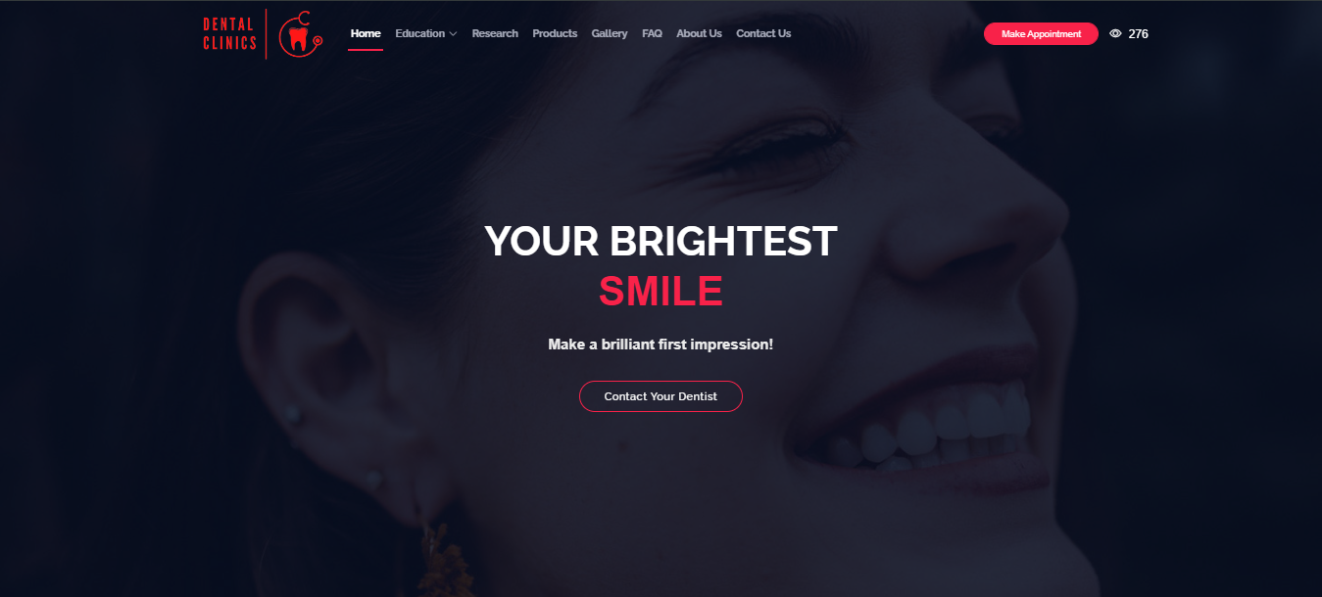

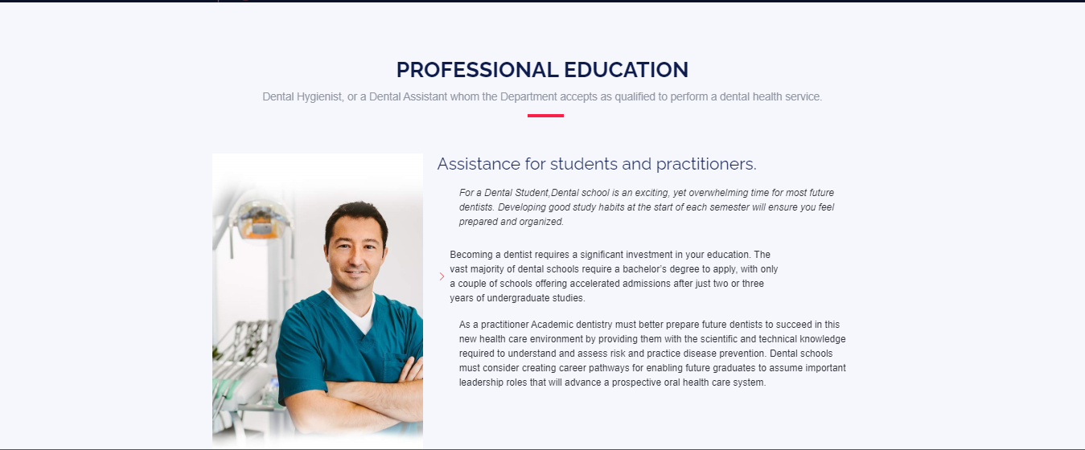

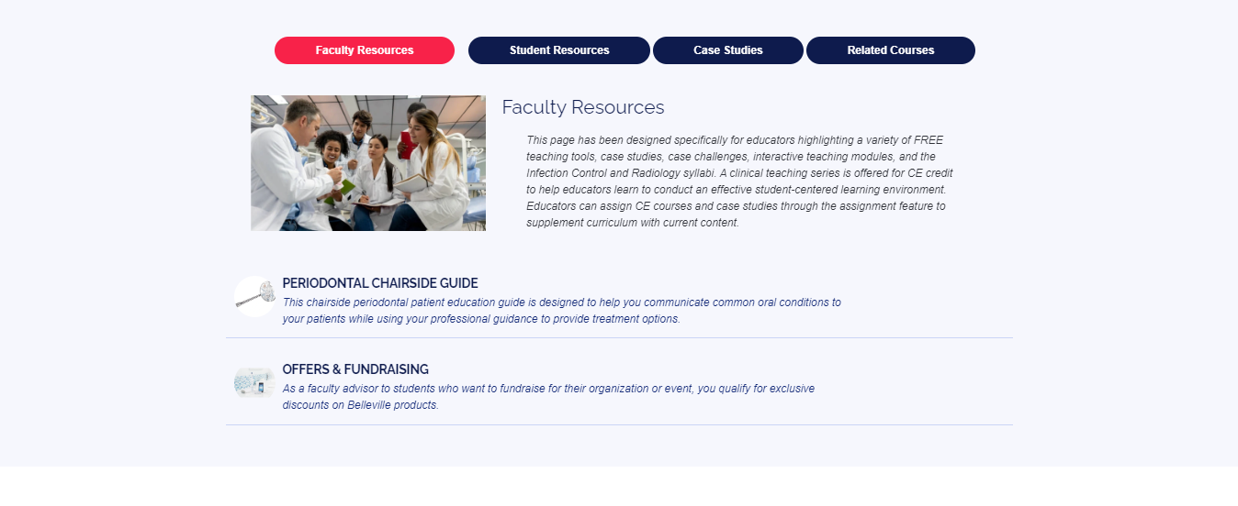

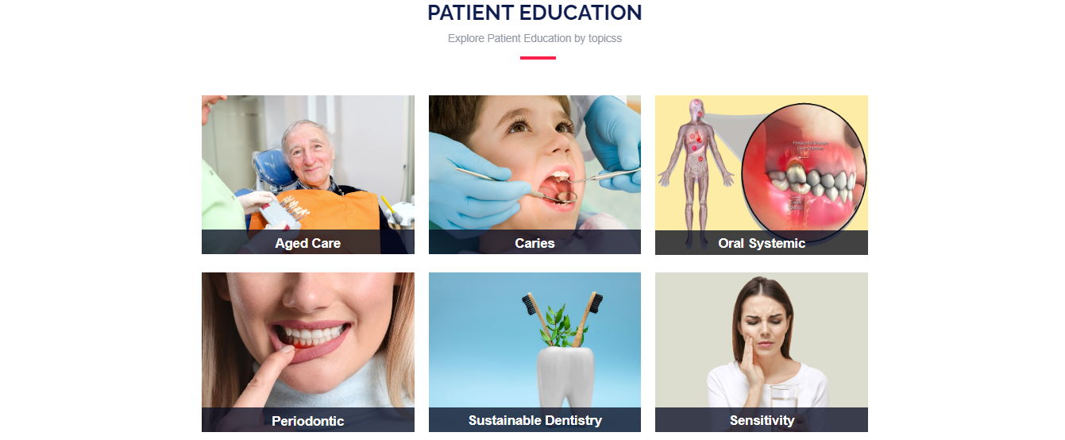

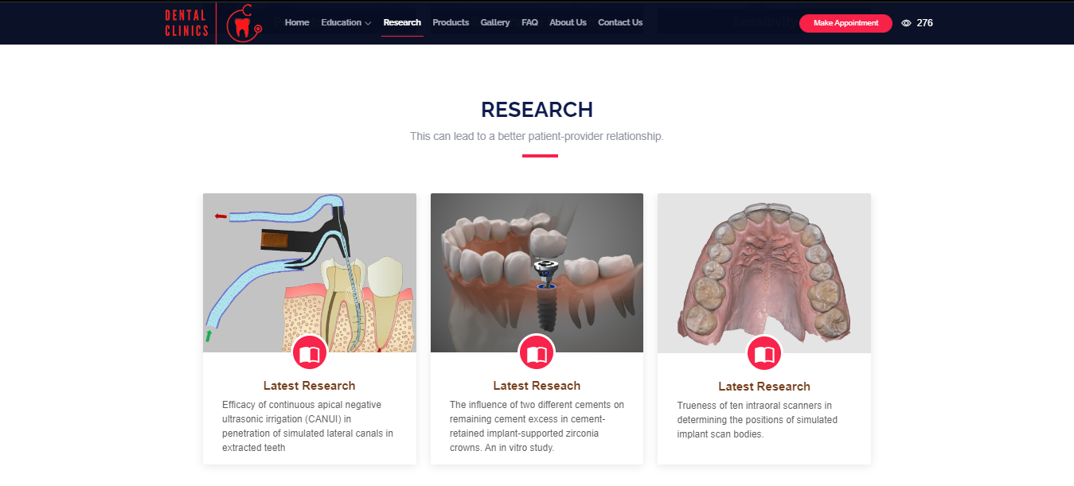

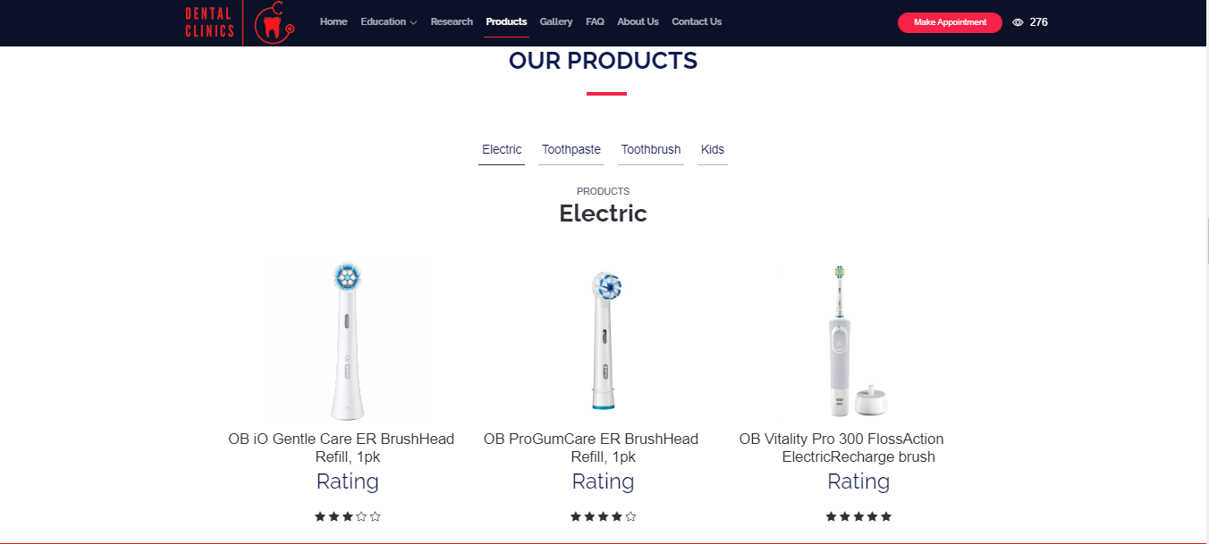

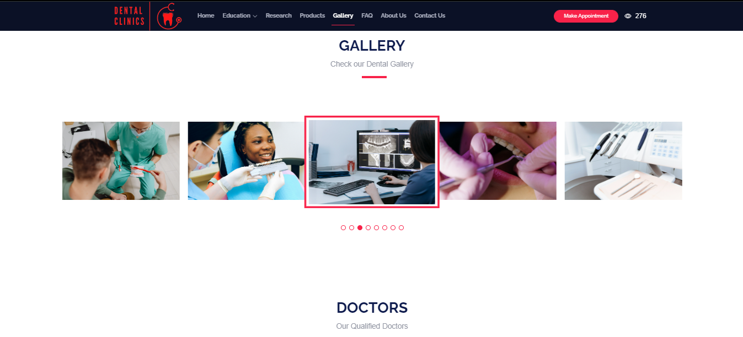

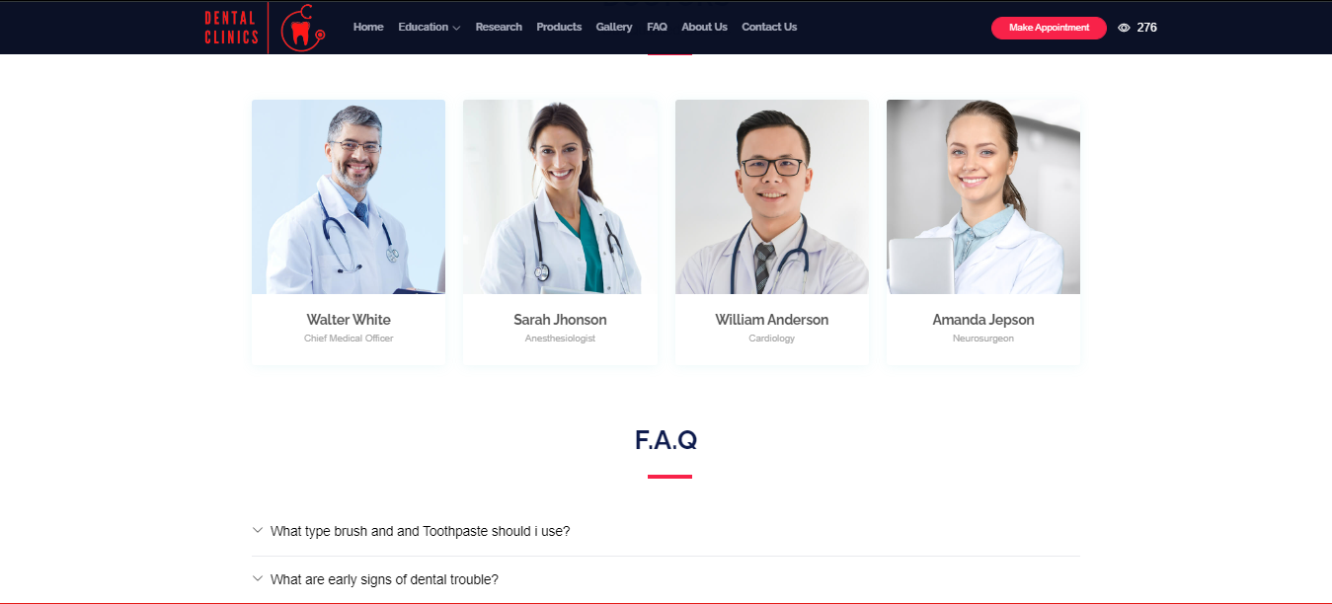

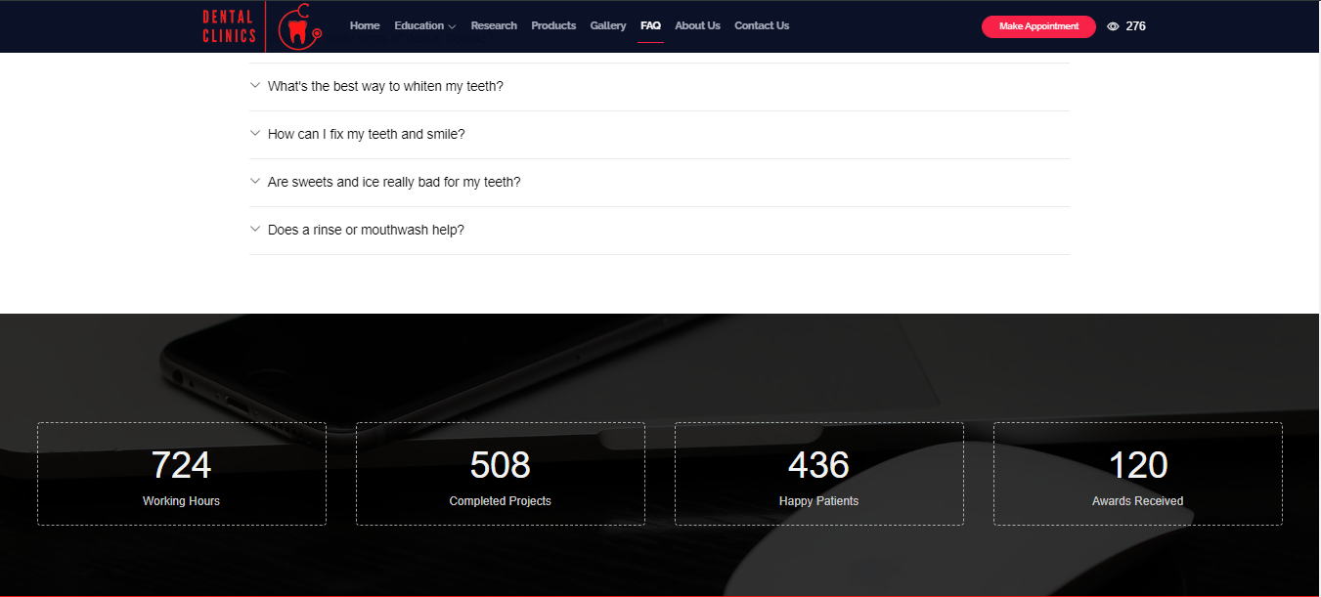

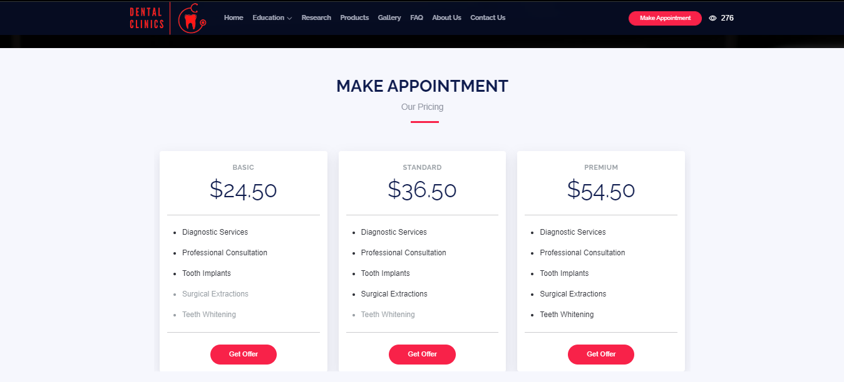

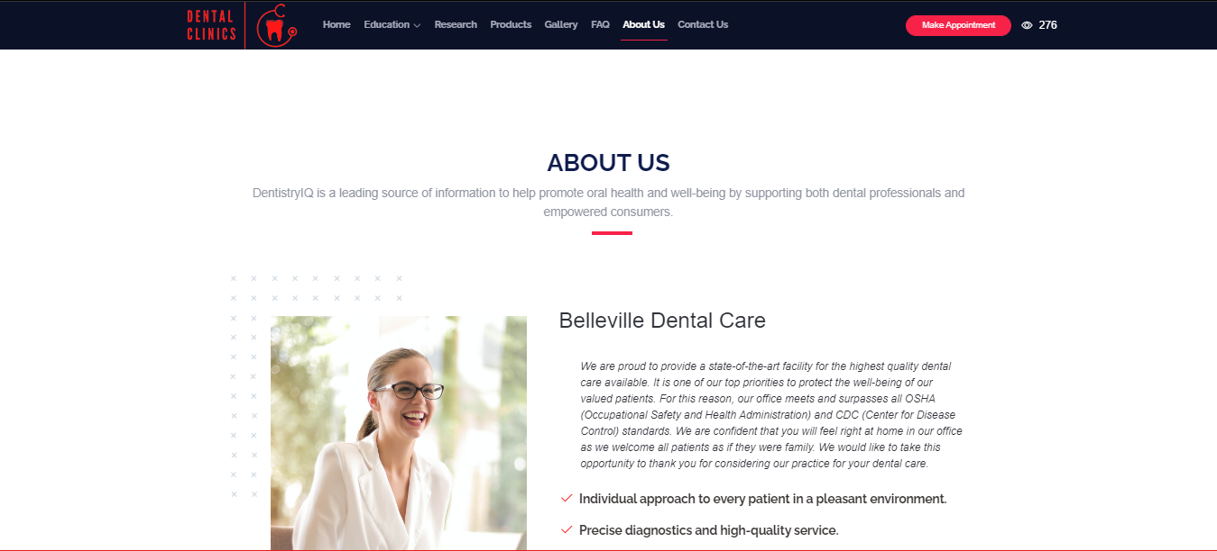

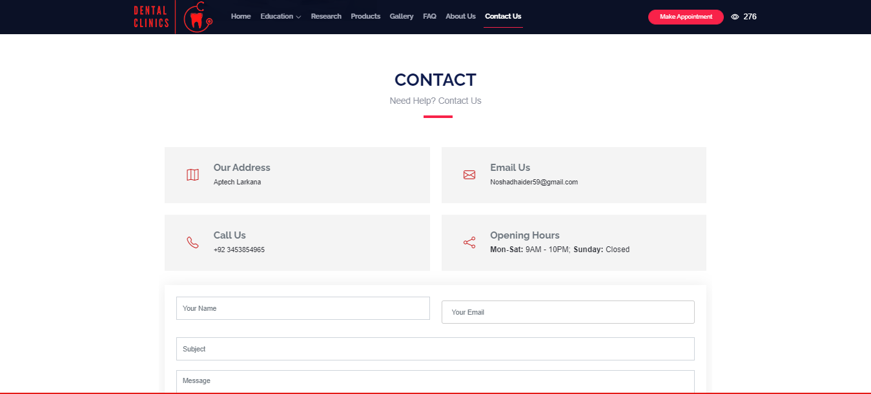

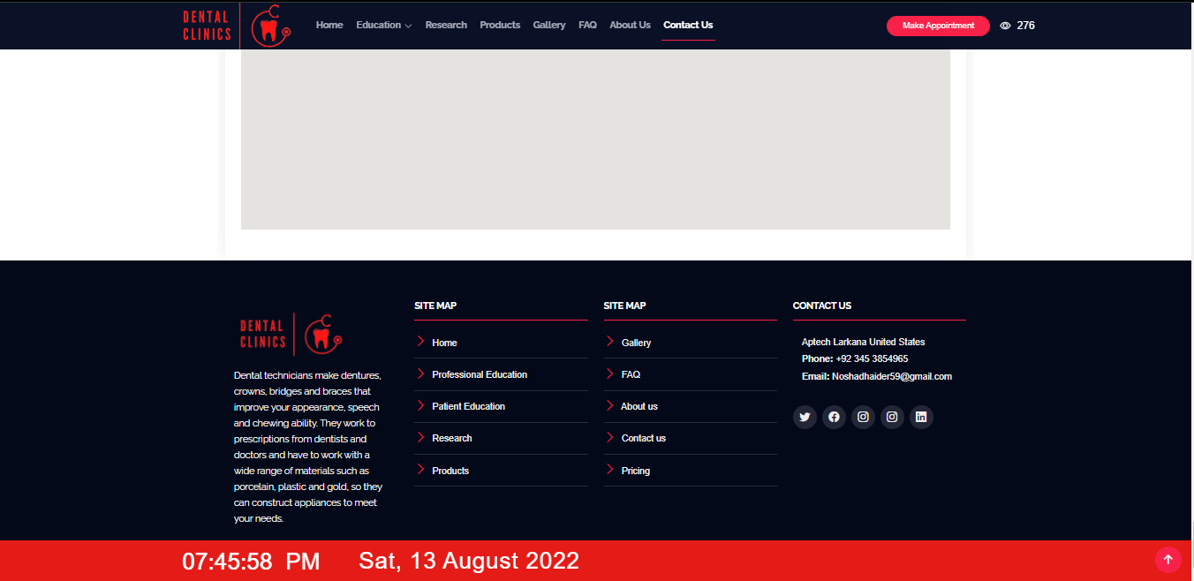

5.Welcome to Navigation Bar

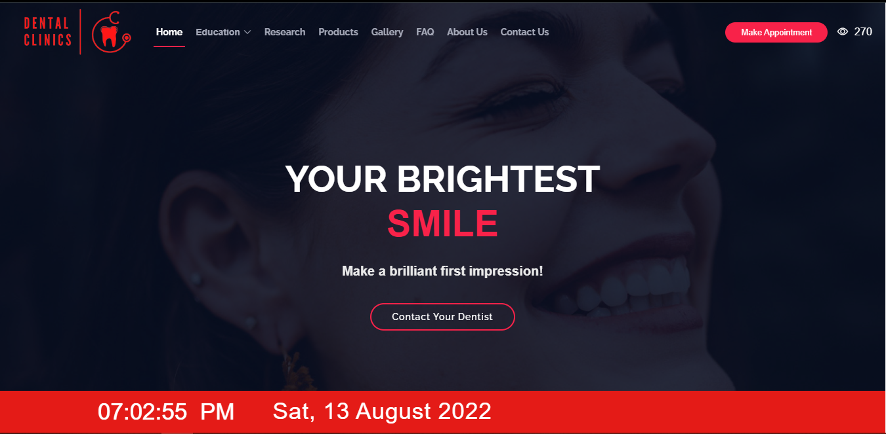

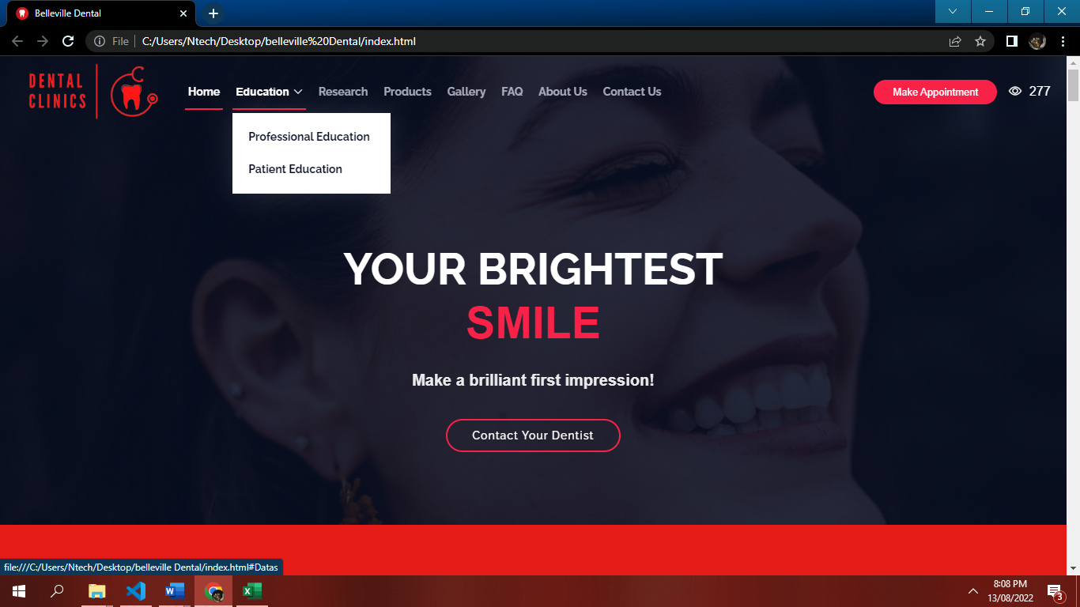

6.Header Section



07. Education Section

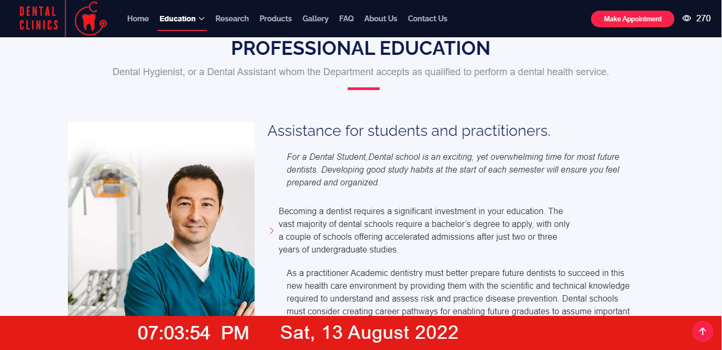

Faculty Resources

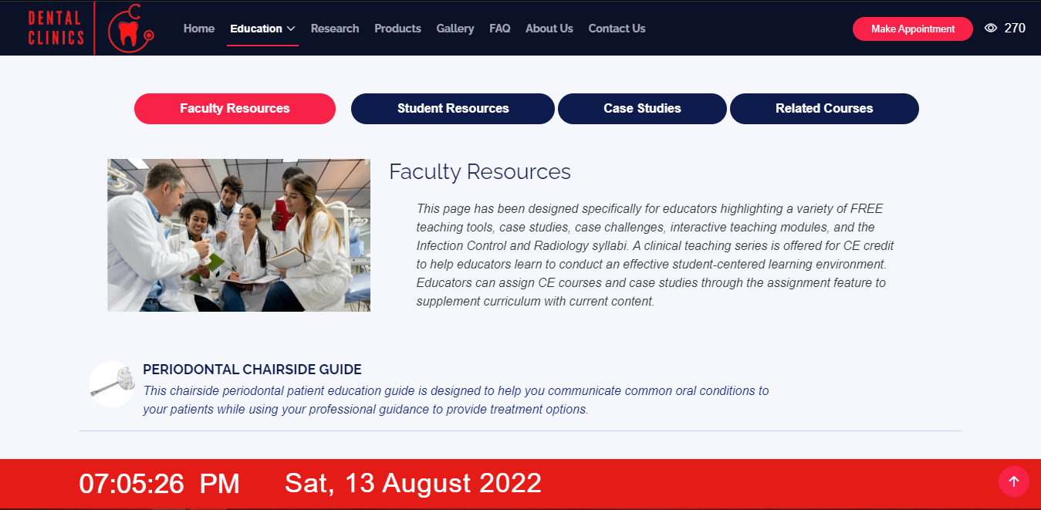

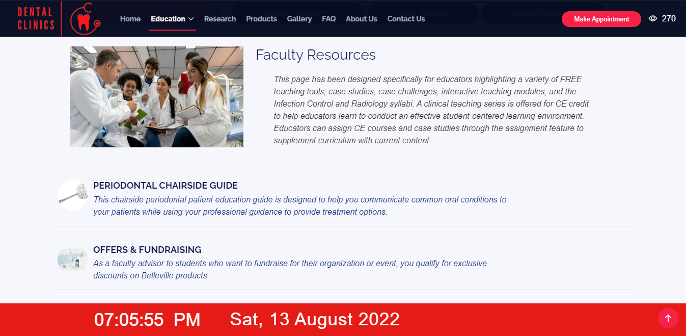

Student Resources

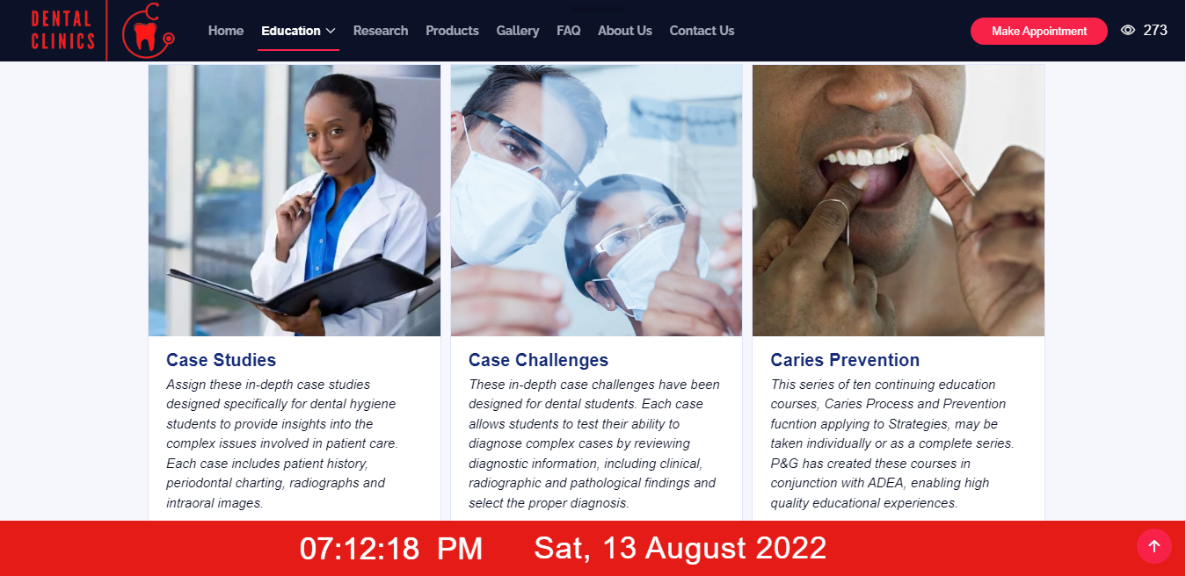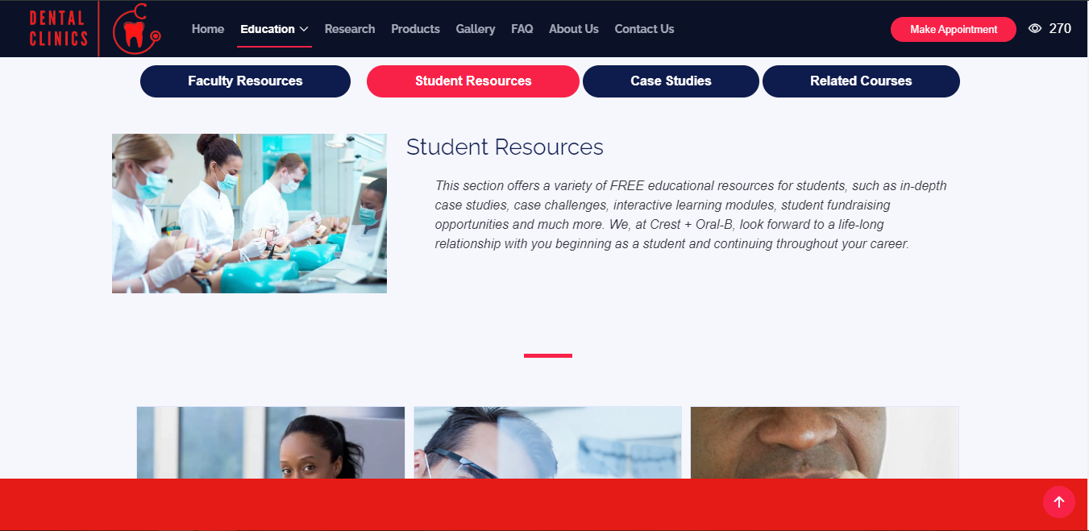

Student Resources Page

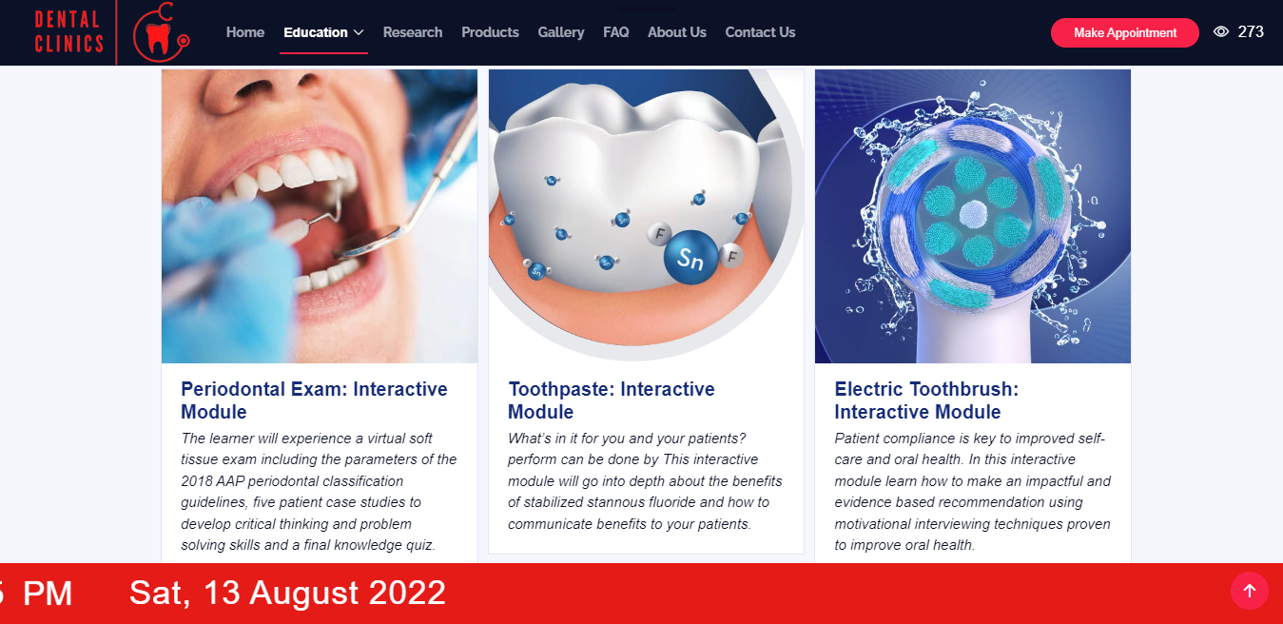

Case Studies

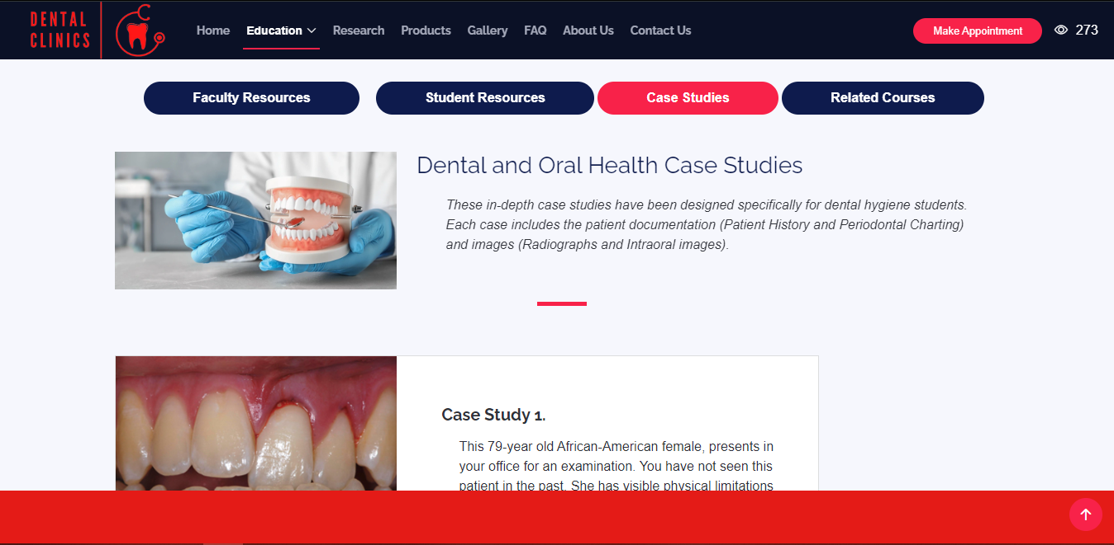

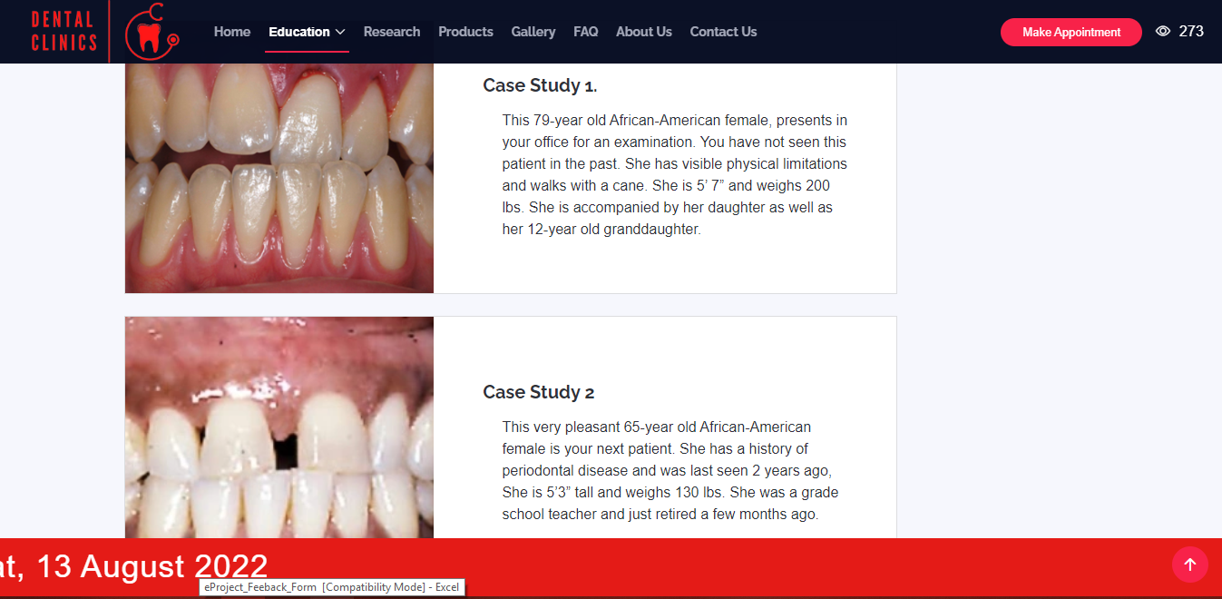

Related Courses

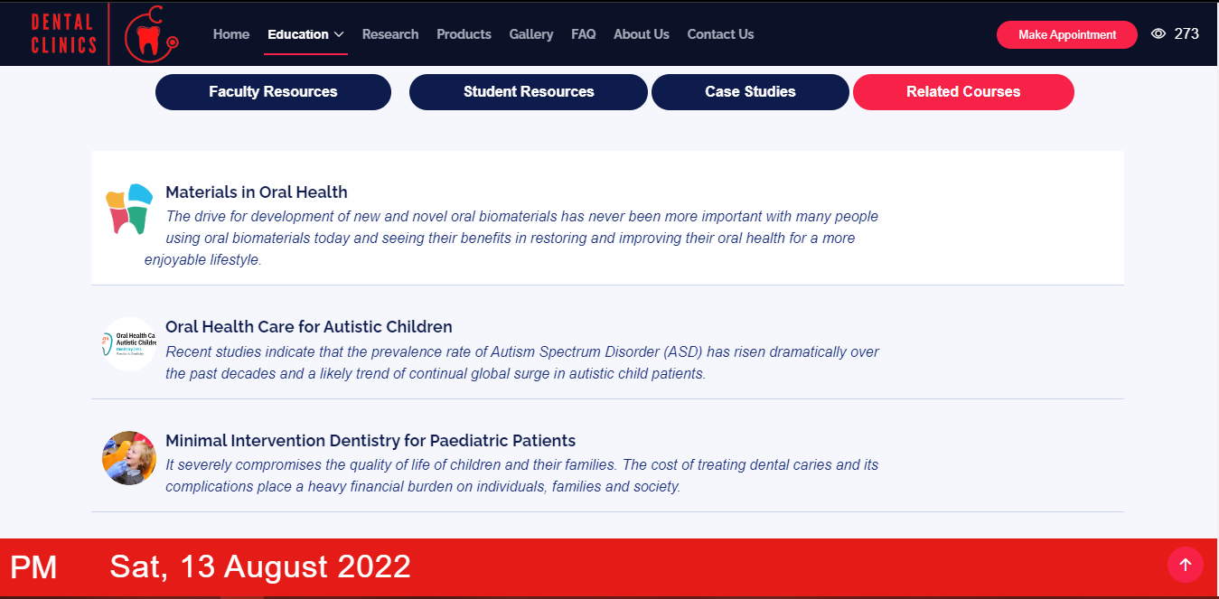

8.Patient Education Section

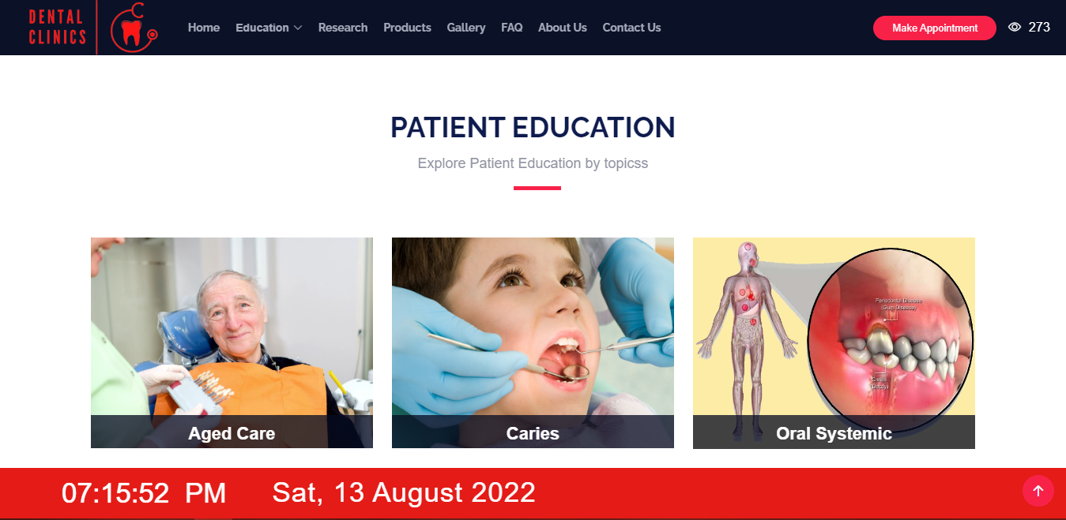

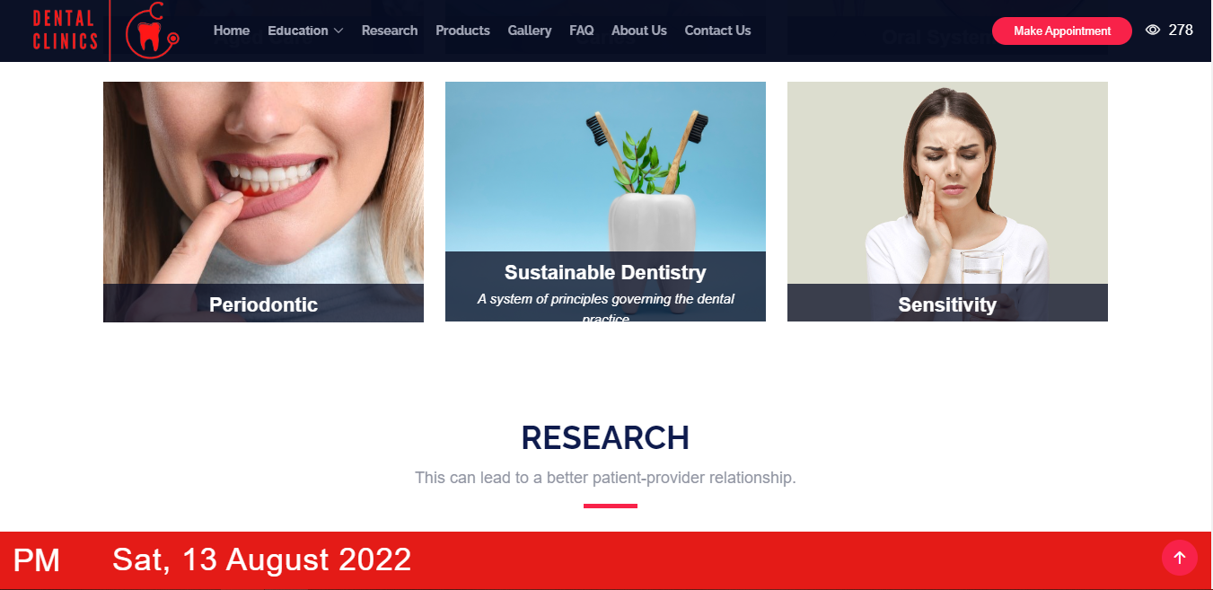

9.Research Section

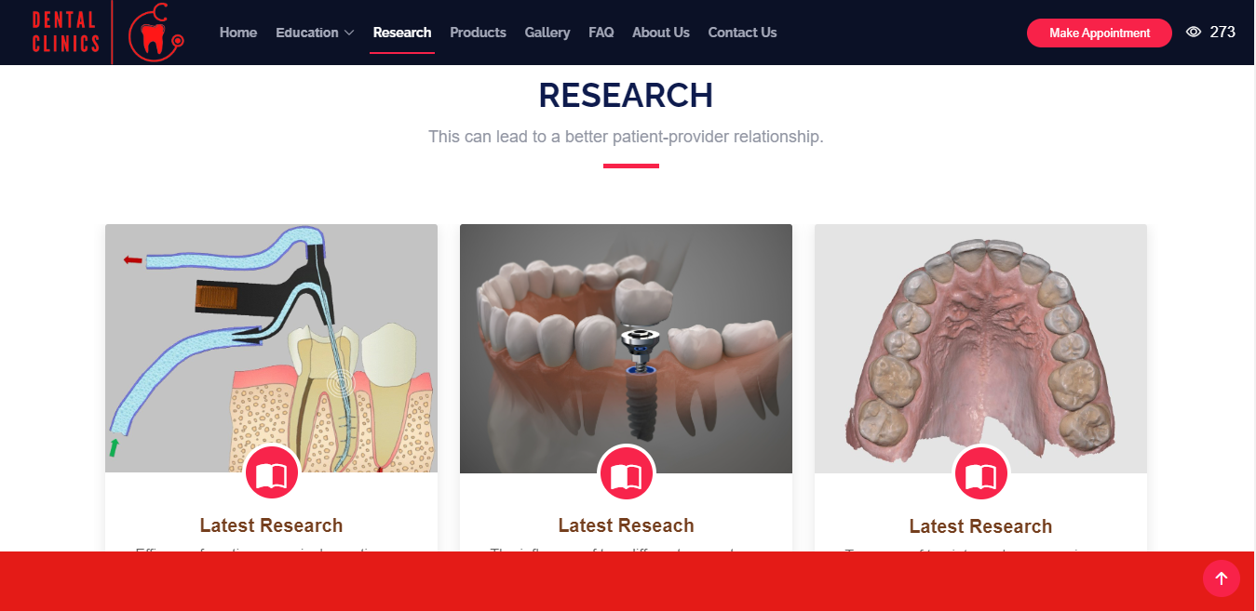

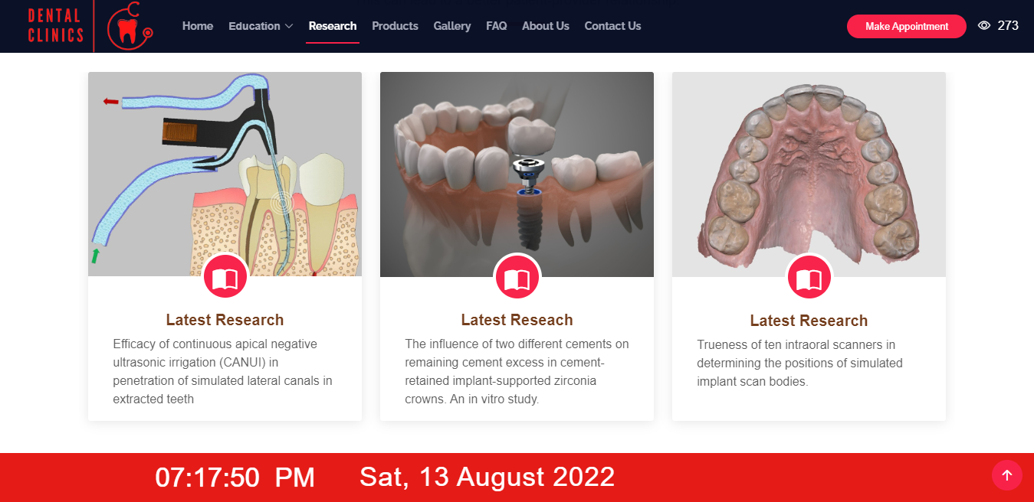

10.Products Section

Electric

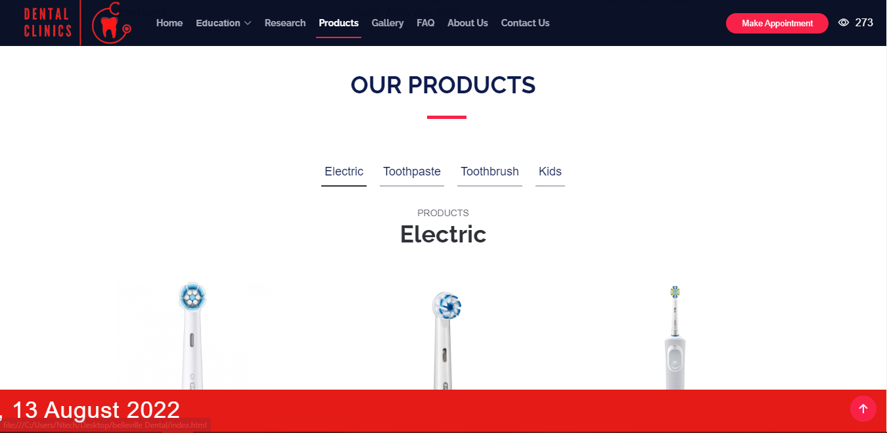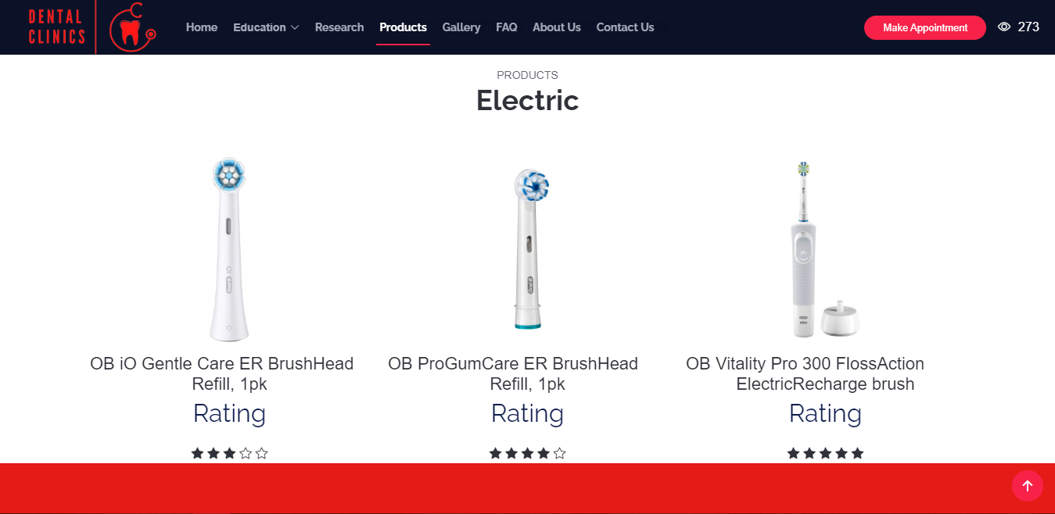

Toothpastes

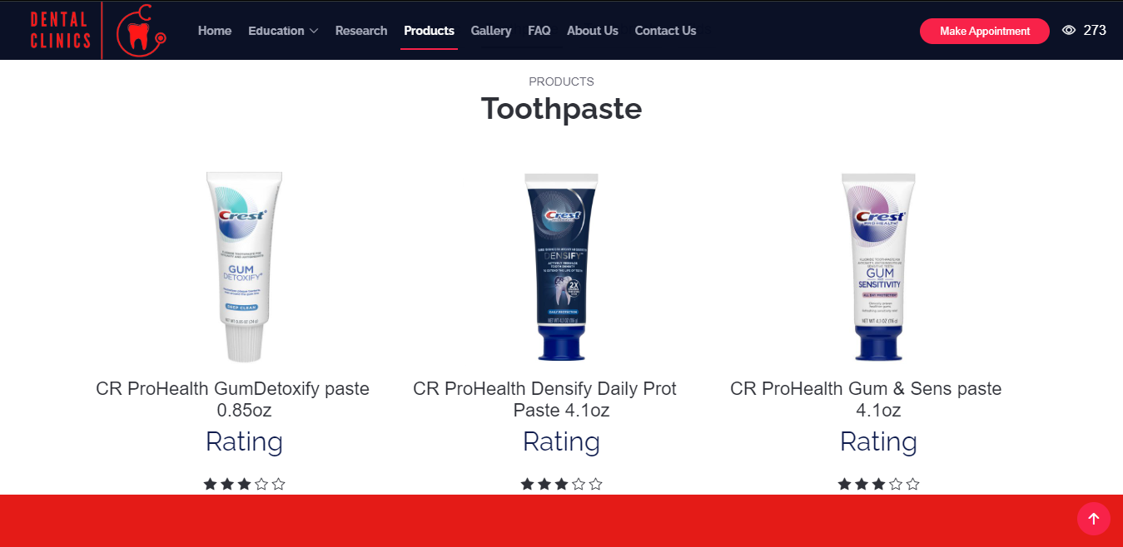

ToothBrush

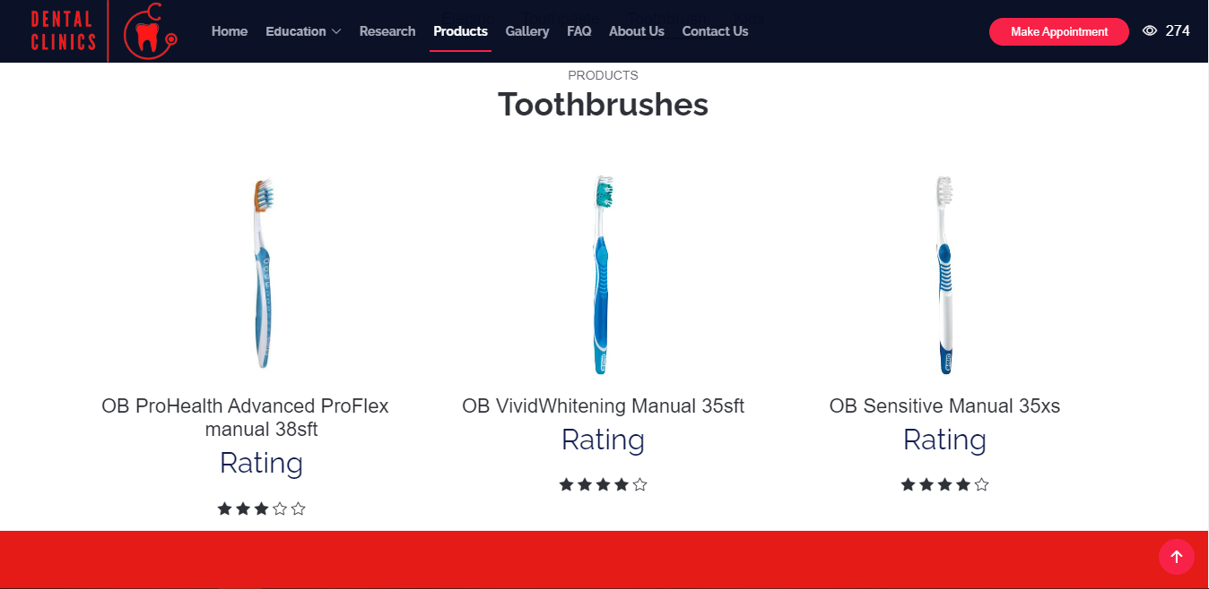

Kids Products

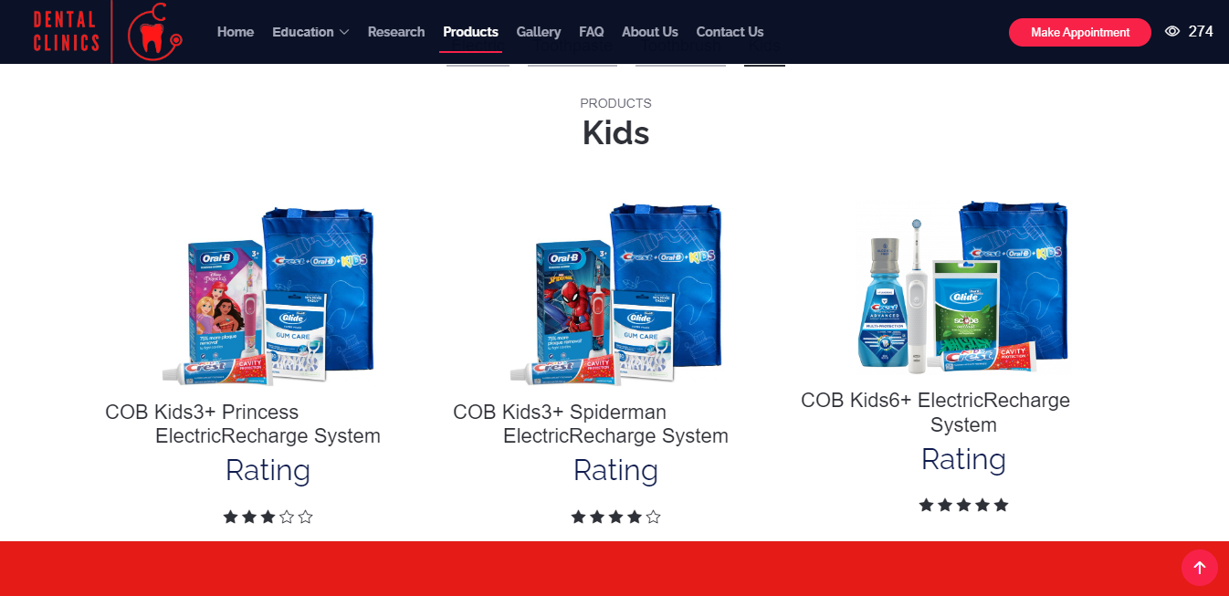

11. Gallery Section

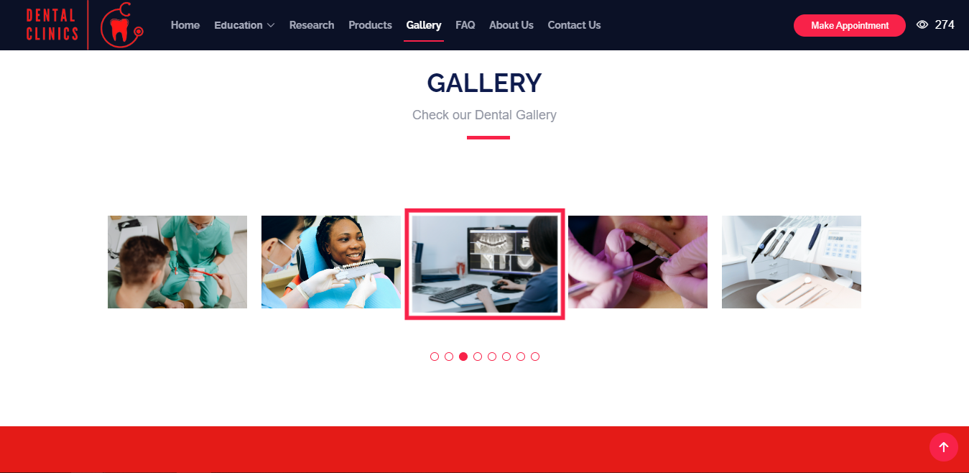

12.DoctorSection

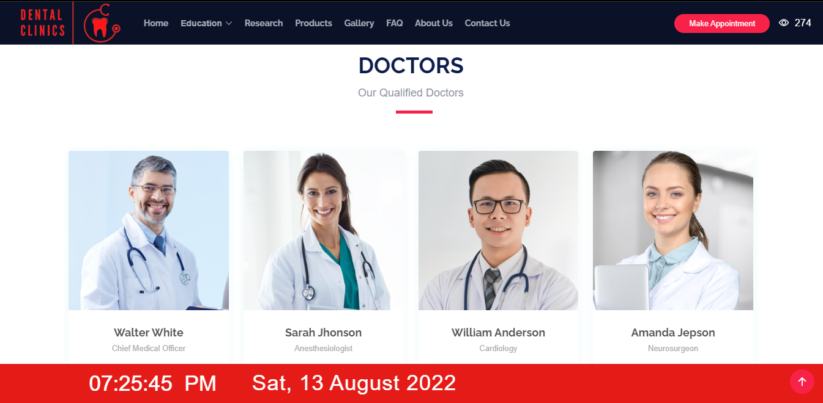

13.F.A.Q Section

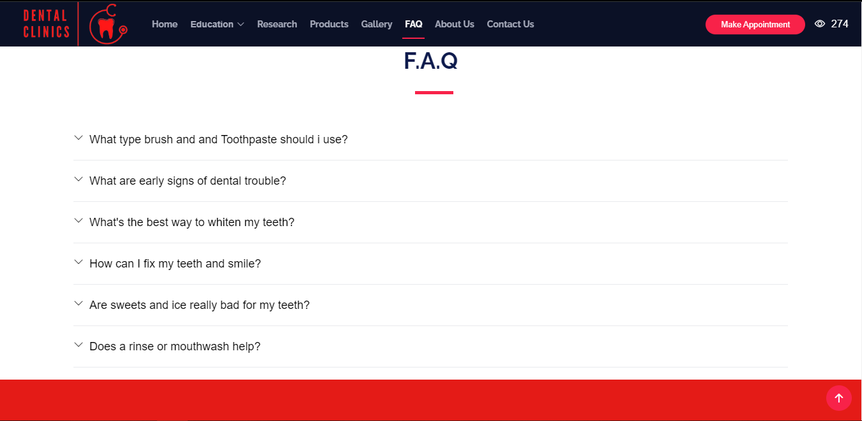

14.Appointment Section



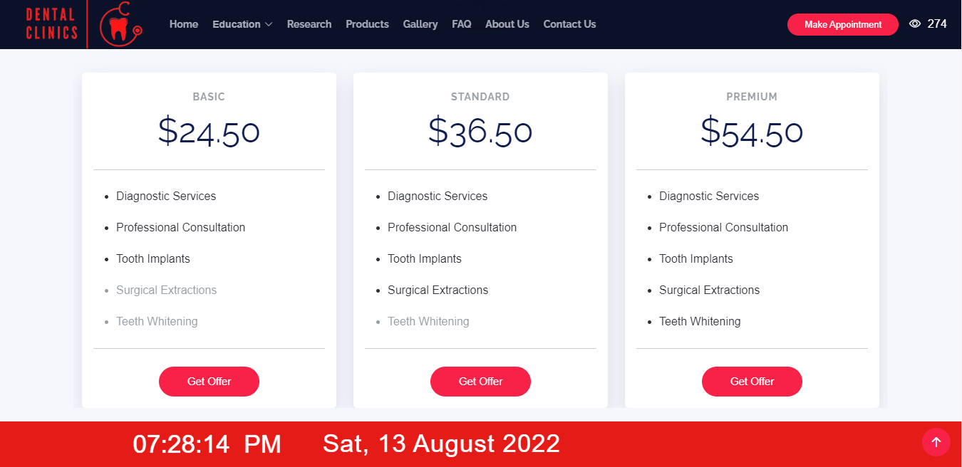

15.About Us

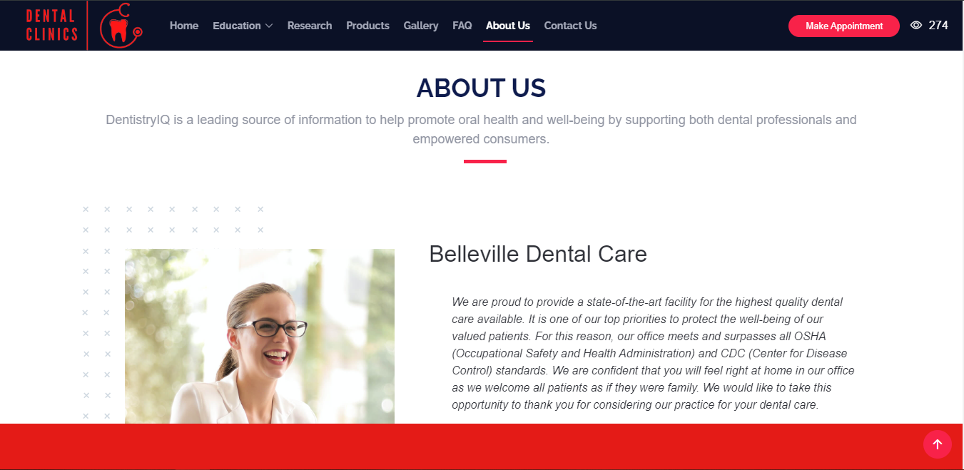

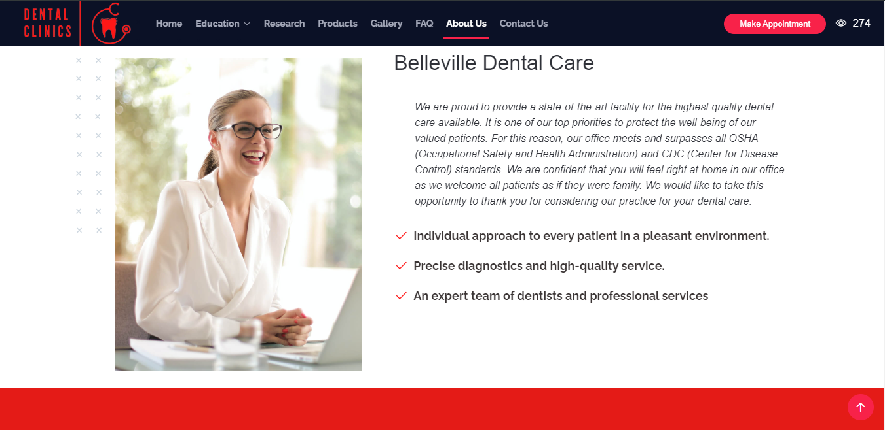

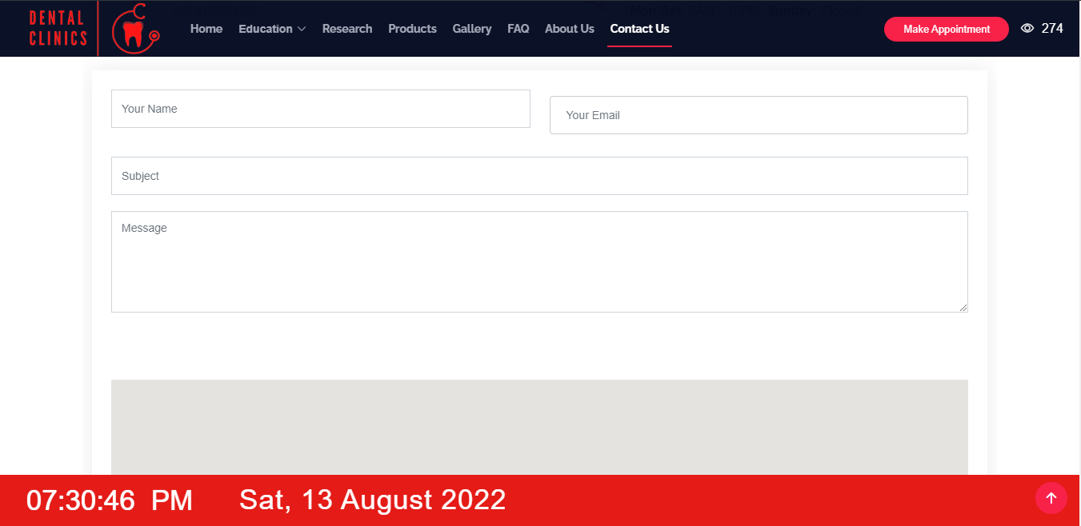 16.Contact Section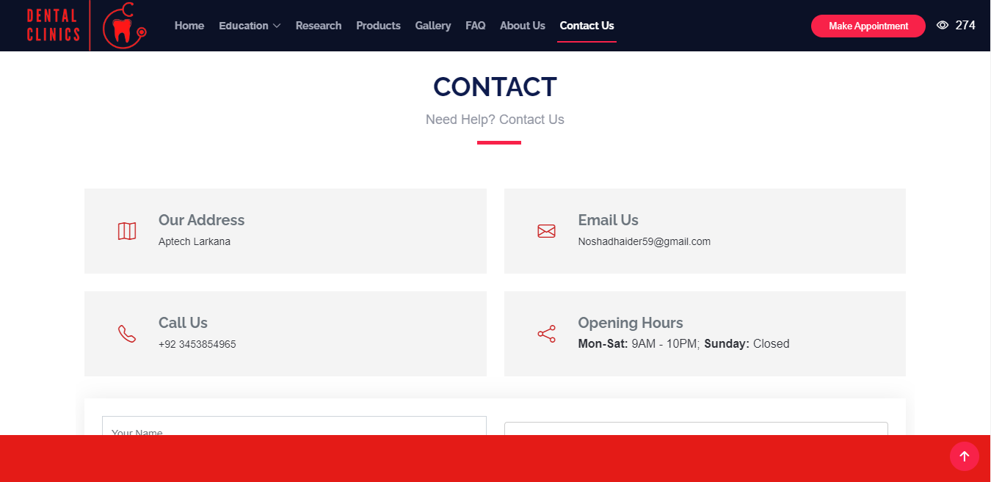

17.Footer Section

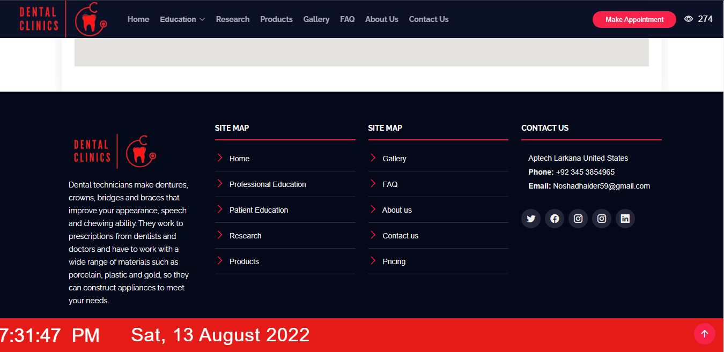

12. Tools

**Hardware/ Software Requirements**

**Hardware**

* Intel Core i3/i5 Processor or higher
* 8 GB RAM or above
* Color SVGA
* 500 GB Hard Disk space
* Mouse
* Keyboard

**Software**

Technologies to be used:

* Frontend: HTML5, CSS, Bootstrap, JavaScript, jQuery, AngularJS, XML
* Data Store: JSON files or TXT files

Other Requirements:

* Operating Portal: Windows
* Browsers: Edge, Chrome, Mozilla Firefox, Safari